Table of contents
Table of contents 1
HTML 3
Differences between: Ordered list - Unordered list - Description list 3
Differences between: Absolute path - Relative path 3
Write HTML codes to construct table (table,tr,td,rowspan,colspan): 4
Suggest appropriate input controls for form fields based on a given scenario (14) **HTML codes NOT required. 4
CSS 5
Differences between: Inline CSS - Embedded CSS - External CSS **CSS codes NOT required. 5
Differences between: Color names - RGB color values - HEX color values ** CSS Codes NOT required 5
JS 6
Differences between: Inline JS - Embedded JS - External JS ** JS codes NOT required. 6
3 Examples of JS / jQuery events: ** JS codes NOT required. 6
PHP 6
3 general data types in PHP: 6
- Scalar: Integer, Float, String and Boolean 6
- Compound: Array and Object 6
- Special: Resource and Null 7
Loose Data Type: 7
Write simple PHP codes to demonstrate loose data type. For example: 7
Differences between Indexed Array - Associative Array: 7
- Write simple PHP codes to demonstrate differences between indexed array and associative array. For example: 7
- Indexed array 7
- Associative array 7
Differences between include - require - include_once - require_once : 8
Advantages of importing files using include or require 8
What is and why do we need a sticky form? 8
Database 9
Advantages of PDO (PHP Data Object). 9
Advantages of prepared statements and parameterized query. 9
Given $_db and a database table (ERD), write basic PDO and SQL codes to: 10
Differences between fetchAll(), fetch() and fetchColumn() (in words): 11
Involve only the following functions 11
query() function 11
prepare() function 11
execute() function 11
What is a database transaction? 12
Database security practices (remember at least 3 points) 13
Security 14
Input validation vs. input sanitization (differences + examples). 14
Suggest input validation for given data (Example): 14
Output Encoding (definition). 14
Stateless protocol (definition). 14
Session vs. cookie (differences + usage examples). 15
Authentication vs. authorization (differences + examples). 15
Password hashing (definition). 15
Examples of password hashing algorithms: 15
Basic: MD5, SHA1 (less secure) 15
Advanced: SHA256, BCRYPT, ARGON2 15
Key points of password hashing. 16
Enforce password strength or strong password. 16
Validating uploaded files. 16
File upload security practices (remember at least 3 points) 16

HTML

Differences between: Ordered list - Unordered list - Description list
Ordered list | - Used for items follow specific sequences (alphabetical/numerical order)  - Uses <ol> tags with <li> (list items), automatically numbered or ordered.  - Ideal for rankings or steps
Unordered list | - Used for items no need specific order  - Uses <ul> tags with <li>, but no inherent sequence, displaying bullet points.  - Ideal for grouping related items without specific sequence
Description list | - Used for define items and provide corresponding description  - Uses <dl> (description list) with <dt> (term) and <dd> (description) to create pairs.  - Ideal for presenting definition without symbol

Ordered list | Unordered list | Description list
<ol>  <li>Alpha</li>  <li>Beta</li>  <li>Omega</li>  </ol> | <ul>  <li>Potato</li>  <li>Tomato</li>  <li>Quaso</li>  </ul> | <dl>  <dt>Felix</dt>  <dd>is my waifu</dd>  <dd>is a good singer</dd>  <dt>Takoyaki</dt>  <dd>is delicious</dd>  </dl>

Differences between: Absolute path - Relative path
• Identify absolute and relative path to a page based on a given file and folder structure (diagram).

Absolute path | Relative Path
- Specifies a file’s precise location within a computer’s entire folder structure.  - Start with slash.  - Suitable when links are commonly reusable in other pages.  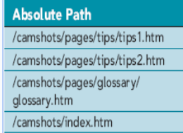 | - Specifies a file’s location in relation to the location of the current document  - Not begin with slash  - Suitable when link not be reused in other page  - Example: ../felix.php, /takoyaki.php  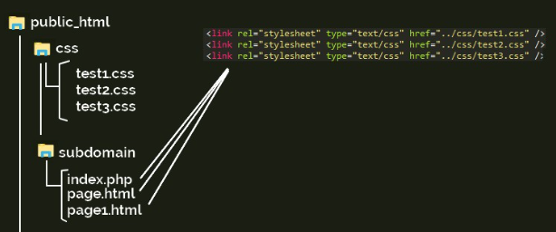

Write HTML codes to construct table (table,tr,td,rowspan,colspan):
<table>  <tr>  <th rowspan="2">Header 1</th>  <th colspan="2">Header 2</th>  </tr>  <tr>  <th>Subheader 1</th>  <th>Subheader 2</th>  </tr>  <tr>  <td>Row 1, Col 1</td>  <td>Row 1, Col 2</td>  <td>Row 1, Col 3</td>  </tr>  <tr>  <td rowspan="2">Row 2, Col 1</td>  <td>Row 2, Col 2</td>  <td>Row 2, Col 3</td>  </tr>  <tr>  <td>Row 3, Col 2</td>  <td>Row 3, Col 3</td>  </tr>  </table> | 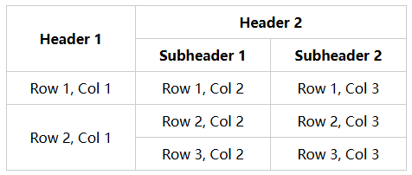

Suggest appropriate input controls for form fields based on a given scenario (14) **HTML codes NOT required.
- Textbox: For short, single-line text entries (e.g., names, email addresses).
- Textarea: For longer, multi-line text (e.g., comments, descriptions).
- Checkbox: For selecting one or more independent options (e.g., "Subscribe to newsletter").
- Radio button list: For choosing one option from a list of mutually exclusive choices (e.g., gender selection).
- Single-selection list: For selecting one option from a dropdown menu (e.g., country selection).
- Checkbox list: For selecting multiple options from a list (e.g., selecting multiple hobbies).
- Multi-selection list: For selecting more than one option from a dropdown menu (e.g., choosing multiple skills).
- Password field: For secure text input, like passwords (masked characters).
- Slider: For selecting a value or range within a scale (e.g., adjusting volume).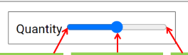
- Spinner: For selecting a number by incrementing or decrementing (e.g., selecting quantity).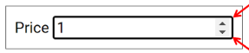
- Date picker: For selecting a date (e.g., booking a flight).
- Time picker: For selecting a time (e.g., setting an appointment time).
- Color picker: For selecting a color (e.g., choosing a color theme).
- File picker: For uploading a file (e.g., attaching a resume).

CSS

Differences between: Inline CSS - Embedded CSS - External CSS **CSS codes NOT required.
Inline CSS | - css rules are placed directly within HTML element using style attribute  - affects only specific elements applied to  - not reusable  <p style="color: blue">Halo</p>
Embedded CSS | - css rules placed within HTML page using <style>  - affects elements within same page  - page level reusability  <style>  p {  color: blue;  }  </style>
External CSS | - css rules are stored in a separate .css file, referenced in the HTML document using the <link> tag.  - affects all linked page  - site level reusability  <link rel="stylesheet" href="styles.css">

Differences between: Color names - RGB color values - HEX color values ** CSS Codes NOT required
• Their advantages and disadvantages.
 | Pros | Cons
Color names | ✅Easy to remember and use (e.g., "red", "blue").  ✅Readable and descriptive.  ✅No need to remember many values. | ❌Limited selection (only a few standard colors).  ❌Lack of precision for shades and tones.  ❌Not suitable for complex or customized colors.
RGB color values | ✅Precise control over color by adjusting red, green, and blue components.  ✅Support 256^3 unique colors  ✅Supports transparency with rgba() (alpha channel). | ❌Values can be long and less readable (e.g., rgb(255, 0, 0)).  ❌Harder to memorize compared to color names.  ❌Not as compact as HEX codes.
Hex color values | ✅Precise control and widely supported format (e.g., #FF0000 for red).  ✅Support 256^3 unique colors  ✅Commonly used in web design and easy to convert from RGB. | ❌Less readable compared to color names.  ❌Harder to adjust individual color components manually.  ❌Doesn’t directly support transparency (though #RGBA format exists).

JS

Differences between: Inline JS - Embedded JS - External JS ** JS codes NOT required.
Inline JS | - JavaScript code are placed directly within HTML element using the onclick or other event attributes  - affects only specific elements applied to  - not reusable  <button onclick="alert('Hello!')">Click me</button>
Embedded JS | - JavaScript code placed within HTML page using <script>  - affects elements within same page  - page level reusability  <script>  alert('Hello');  </script>
External JS | - JavaScript code is stored in a separate .js file, referenced in the HTML document using the <script> tag.  - affects all linked page  - site level reusability  <script src="script.js"></script>

3 Examples of JS / jQuery events: ** JS codes NOT required.
- Moving the mouse over an element (e.g. image)
- Selecting a radio button or checkbox
- Clicking on an element (e.g. button)

PHP

3 general data types in PHP:
- PHP does not differentiate between string and character types.
- PHP does not differentiate between float and double types.
- Scalar: Integer, Float, String and Boolean  → Contains a single value | Subtypes:  Integer: A whole number (e.g., 15).  Float: A floating-point number (e.g., 3.5).  String: A series of characters (e.g., "Hello, World").  Boolean: Represents either true or false (e.g., true or false).
- Compound: Array and Object  → Contains more than one value | Subtypes:  Array: A list of values referenced by names or indices (e.g., $fruits = array("apple", "banana", "cherry");).  Object: A type that contains properties and methods (e.g., $car = new Car(); where Car is a class with its properties and methods).
- Special: Resource and Null  → Neither scalar nor compound but they have special meaning | Subtypes:  Resource: Contains a reference to an external resource, such as a file or database connection (e.g., $file = fopen("example.txt", "r");).  Null: Contains a null value, indicating no value or no data (e.g., $var = null;).

Loose Data Type:
- Definition | allows variable declarations without specifying a data type.  PHP automatically determines the type based on the assigned value.
- Example | Write simple PHP codes to demonstrate loose data type. For example:  $value = 123; // $value is integer  $value = 'A'; // $value is string now
- Advantages | - Allows flexible variable declaration without type specification.  - Same variable can hold different data types, useful for quick prototyping.  - Enables focus on logic without worrying about data types.
- Disadvantages | - Difficult to identify errors, especially with unintended type mismatches.  - Runtime issues can complicate debugging.  - Implicit隐式 type conversion may cause unexpected results.

Differences between Indexed Array - Associative Array:

- Write simple PHP codes to demonstrate differences between indexed array and associative array. For example:
- Indexed array  → numeric index | Uses numeric index to access elements.
  $x = [  'Apple',  'Banana',  'Coconut',  ]; // $x is an indexed array  echo "Indexed Array:\n";  foreach ($x as $index => $value) {  echo "Index $index: $value\n";  } | Indexed Array:  Index 0: Apple  Index 1: Banana  Index 2: Coconut
- Associative array  → string key | Uses string keys to access elements.
  $b = [  'APP' => 'Apple',  'BNN' => 'Banana',  'CCN' => 'Coconut',  ]; // $b is an associative array  echo "Associative Array:\n";  foreach ($b as $key => $value) {  echo "Key $key: $value\n";  } | Indexed Array:  Index 0: Apple  Index 1: Banana  Index 2: Coconut  Associative Array:  Key APP: Apple  Key BNN: Banana  Key CCN: Coconut

Differences between include - require - include_once - require_once :
include | require | include_once | require_once
Imports a file and continues running if not found, producing a warning. | Imports a file and stops execution if not found, producing a fatal error. | Same as include, but imports the file only once. | Same as require, but imports the file only once.
include '_head.php'; | require '_base.php'; | include_once 'Custom.php'; | require_once 'Custom.php';

Advantages of importing files using include or require
- Enables shared functions and libraries across multiple pages.
- Ensures consistent design by reusing layouts.
- Simplifies pages by breaking them into manageable components.
- Organizes related components into separate files.
- Makes maintenance easier, as updates to one file propagate to all linked pages.

What is and why do we need a sticky form?
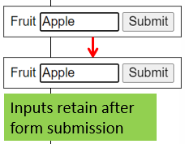
Definition: A sticky form retains user inputs even after form submission.
Purpose:
It allows users to review and correct input errors before resubmit the form, enhance user experience by preventing data loss.
<?php
require '_base.php';

if (is_post()) {
$fruit = req('fruit');
// other code details
}
?>

<form method="post">
<label for="fruit">Fruit</label>
<input type="text" id="fruit" name="fruit" value="<?= $fruit ?? '' ?>" maxlength="100">
<button>Submit</button>
</form>

Database

Advantages of PDO (PHP Data Object).
- Follows an object-oriented coding style for better organization.
- Works with multiple databases (e.g., MySQL, SQLite, Oracle) using specific PDO drivers.
- Provides a consistent data-access abstraction layer for queries and data fetching across different databases.
- Easier to change database as minimal rewrites of SQL statements are needed

Advantages of prepared statements and parameterized query.
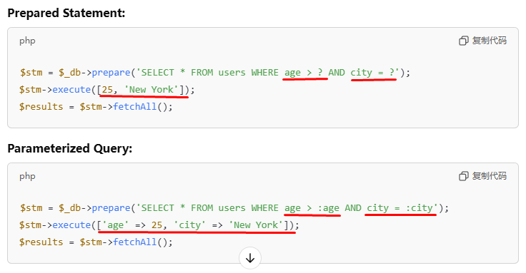
Prepared Statements: | Parameterized Queries:
Precompile the SQL query, allowing it to be executed multiple times with different values. | Use placeholders for inputs, which are provided later when the query is executed.
Advantages  Query is compiled once and reused.  Prevents SQL injection  Reusability - same query different inputs | Protection from SQL injection as inputs automatically escape  Named parameter make queries clearer  Allows easy insertion of dynamic values
Both fall under Prepared Statements and are examples of Parameterized Queries:
Positional Parameters  (?) | // example  $min = 1.00;  $max = 3.00;  $stm = $_db->prepare('SELECT * FROM fruit  WHERE price >= ? AND price <= ?');  $stm->execute([$min, $max]);  $arr = $stm->fetchAll();
Named parameters  (:name) | // example  $min = 1.00;  $max = 3.00;  $stm = $_db->prepare('SELECT * FROM fruit  WHERE price >= :min AND price <= :max');  $stm->execute(['min' => $min, 'max' => $max]);  $arr = $stm->fetchAll();

Given $_db and a database table (ERD), write basic PDO and SQL codes to:
Operation | Sample Code
SELECT all records | $stm = $_db->query('SELECT * FROM fruit');  $arr = $stm->fetchAll();  foreach ($arr as $f) {  echo "$f->id | $f->name | $f->price<br>";  }  // 1 | Apple | 1.00  // 2 | Banana | 2.00  // 3 | Coconut | 3.00
SELECT one or first record | $f = $_db->query('SELECT * FROM fruit')  ->fetch();  echo "$f->id | $f->name | $f->price<br>";  // 1 | Apple | 1.00
SELECT one or first column | $id = $_db->query('SELECT * FROM fruit')  ->fetchColumn();  echo "$id<br>";  // 1
SELECT one single value | $count = $_db->query('SELECT COUNT(*) FROM fruit')  ->fetchColumn();
SELECT key-value pairs | $items = $_db->query('SELECT id, name FROM fruit')  ->fetchAll(PDO::FETCH_KEY_PAIR);  <?= html_select('fruit', $items) ?>
INSERT a record | $id = 4;  $name = 'Durian';  $price = 4.00;  $stm = $_db->prepare('INSERT INTO  fruit (id, name, price)  VALUES (?, ?, ?)');  $stm->execute([$id, $name, $price]);
UPDATE a record | $id = 4;  $name = 'Durian (Musang King)';  $price = 90.00;  $stm = $_db->prepare('UPDATE fruit  SET name = ?, price = ?  WHERE id = ?');  $stm->execute([$name, $price, $id]);
UPDATE multiple record | $stm = $_db->prepare('UPDATE fruit  SET price = price + 1.00');  $stm->execute();  $count = $stm->rowCount();  echo "$count record(s) updated"; // 5 record(s) updated
DELETE a record | $id = 4;  $stm = $_db->prepare('DELETE FROM fruit WHERE id = ?');  $stm->execute([$id]);
DELETE all records | $stm = $_db->query('DELETE FROM fruit');  $count = $stm->rowCount();  echo "$count record(s) deleted"; // 5 record(s) deleted

Differences between fetchAll(), fetch() and fetchColumn() (in words):
fetchAll() | Return multiple records as an array of objects
fetch() | Return one record as an object
fetchColumn() | Return one scalar value

Involve only the following functions
query() function  It runs the SQL query directly without needing prepare() or placeholders. | $stm = $_db->query('SELECT * FROM fruit');  $arr = $stm->fetchAll(); // Directly runs the query and fetches results  Use query() when the query is static.
query() = prepare() + execute() (without parameters)
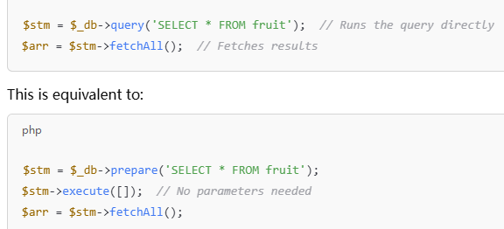
prepare() function  It creates a query template, but it doesn't run the query yet. It just prepares the query with placeholders (if needed) for later use. | $stm = $_db->prepare('SELECT * FROM fruit WHERE id = ?');  - It returns you a PDOStatement object, which can later execute.  - Use prepare() when you need to pass dynamic values securely.  - can be executed multiple times (don't need to prepare the query again if you just want to change the values.)  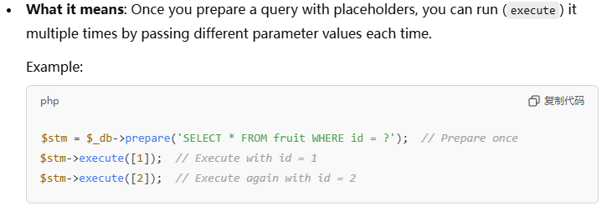
execute() function  This runs the query, and you provide the actual values (parameters) when you call execute(). | $id = 1;  $stm->execute([$id]); // Runs the query, replacing ? with 1  $arr = $stm->fetchAll(); // Fetches the results

Function involves:  - query()  - prepare()  - execute()  - fetchAll()  - fetch()  - fetchColumn() | Code Example (Provided from lecturer):  - Select all fruits records. Store the result in array $arr. Use query() and fetchAll()  - SELECT a fruit record based on $id. Store the result in variable $f. Use prepare(), execute() and fetch() functions in your solution.  - SELECT the COUNT of all fruit records. Store the result in variable $count. Use query() and fetchColumn() functions in your solution.  - INSERT a fruit record using inputs stored in $id, $name and $price. Use prepare() and execute() functions in your solution.
  $arr = $_db->query(‘SELECT * FROM fruit’)->fetchAll();
  $stm = $_db->prepare(‘SELECT * FROM fruit WHERE id = ?’);
  $stm->execute([$id]);
  $f = $stm->fetch();
  $count = $_db->query(‘SELECT COUNT(*) FROM fruit’)->fetchColumn();
  $stm = $_db->prepare(‘INSERT INTO fruit (id, name, price) VALUES (?, ?, ?)’);
  $stm->execute([$id, $name, $price]);

What is a database transaction?
Description | Transaction is used to group a sequence of related database operations together as a single unit.
Function | - Ensure that either all database operations are completed successfully and all changes are committed to the database as a whole.  - If any operation fails, then no changes shall be made to the database at all.
PDO object’s functions to work with transaction | - beingTransaction()  - Start a transaction  - commit()  - Commit all changes made since transaction starts.  - rollBack()  - Cancel all changes made since transaction starts.
Sample Code | $data = [  [1, 'Apple', 1.00],  [2, 'Banana', 2.00],  [3, 'Coconut', 3.00],  ];  $stm = $_db->prepare('INSERT INTO  fruit (id, name, price)  VALUES (?, ?, ?)');  $_db->beginTransaction(); // begin transaction  foreach ($data as $row) {  $stm->execute($row); // execute the SQL but no record will be actually inserted until commit() is called  }  $_db->commit(); // commit all changes to database at once

Database security practices (remember at least 3 points)
- Use prepared statements and parameterized queries (rather than mixing SQL with variables).
- Utilize input validations and output encodings to address special characters (e.g. use the quote() function).
- Use stored procedures to abstract data access and disallow direct access to base tables.
- Applications should use the lowest possible level of privilege when accessing databases (e.g. cannot CREATE or DROP table).
- Create different database accounts for different user roles. Grant only the permissions needed.
- Change the default database administrative username and password (e.g. do not use ‘root’ and “ in production).
- Change the default port number of the database server. If possible, host the database server on a different computer.
- Remove unnecessary default vendor content (e.g. sample schemas or sample tables).
- Turn off unnecessary database functionality (e.g. unnecessary services and packages).
- Turn off or disable database clients (e.g. PHPMyAdmin) when it is not in use.
- Utilize strong passwords. Use multi-factor authentication if the database server supports it.
- Do not hardcode database settings in codes. Store them in a separated and encrypted file.

Security

Input validation vs. input sanitization (differences + examples).
Validation ensures the input is correct; sanitization makes the input safe.
Validation does not change the input, while sanitization modifies it.
Input Validation | Input Sanitization
Check if input meets certain criteria (e.g. length, format)  It does not alter the input | Alter input by removing undesired characters (e.g. HTML tags)  It does not validate the input
Check if an input meets the standard email format  Suggest input validation for given data (Example):  Given ERD and sample data  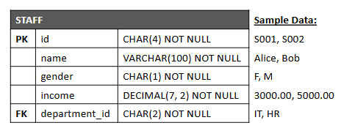  Suggest  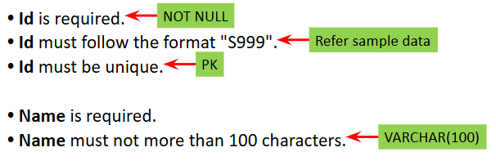  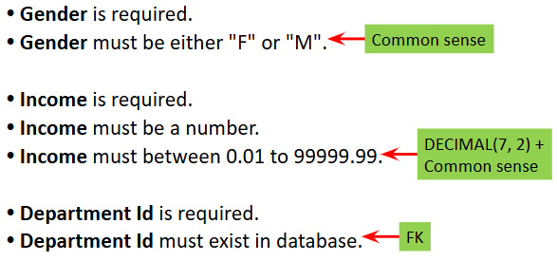 | Remove illegal characters from an email address  General Input Validations:  - Validate the input is filled an not empty (i.e. required)  - Validate the format or pattern (e.g. use regular expression)  - Validate the data type (e.g. number, date)  - Validate the length (e.g. string)  - Validate the minimum value (e.g. number, date)  - Validate the maximum value (e.g. number, date)  - Validate the range (both minimum and maximum value)  - More validations in lecture notes …

Output Encoding (definition). | Stateless protocol (definition).
- involves converting special characters into HTML entities when displaying content from untrusted sources, such as user inputs or database records, to prevent them from being rendered as HTML tags and executed by the browser.  Example: Converting <script> to &lt;script&gt; to avoid executing potentially harmful scripts. | - A stateless protocol, like HTTP, treats each request from a client to the server as an independent transaction, meaning the server does not retain any state information between requests.

Session vs. cookie (differences + usage examples).
HTTP Session | HTTP Cookie
- Server-side data storage for user sessions  - Complex data (objects, arrays)  - Secure; inaccessible to users  - Not accessible by JavaScript  - Short-term; lasts until the browser is closed | - Client-side data storage in the browser  - Simple text data  - Less secure; users can modify it  - Accessible by JavaScript if not set to HTTP-only  - Long-term; can persist until deleted by the user
Login sessions, shopping carts | User preferences, search history

Authentication vs. authorization (differences + examples).
* Authentication comes before authorization (User must be authenticated first, before he can be authorized for access)
Authentication | Authorization
- The process of verifying a user’s identity (e.g., checking email and password). | - The process of granting or denying access to resources based on the authenticated user’s permissions.
A user enters credentials on a login page, and the system verifies them against stored records. | An admin user can edit or delete records, while a regular user can only view them.

Password hashing (definition).
A security technique that transforms user passwords into a fixed-length string of characters, making it difficult to reverse-engineer and exposing only the hashed version rather than the original password.

Examples of password hashing algorithms:
Basic: MD5, SHA1 (less secure) | Advanced: SHA256, BCRYPT, ARGON2
MD5: Widely used but vulnerable to collisions.  SHA1: Also widely used but has known vulnerabilities. | SHA256: Part of the SHA-2 family, providing a higher level of security.  BCRYPT: Specifically designed for hashing passwords, incorporates a salt to protect against rainbow table attacks.  ARGON2: The winner of the Password Hashing Competition, offering strong resistance to brute-force attacks and incorporating memory-hard functions.

Key points of password hashing.
- One-Way Process: Hashing is designed as a one-way function; it's easy to generate a hash from a password, but infeasible to revert it back.
- Same Input, Same Hash: The same password will always produce the same hash when using the same algorithm and salt, allowing for easy verification.
- Salt: A random value added to the password before hashing, ensuring that even identical passwords result in different hashes, enhancing security against precomputed attacks.
- Storing Passwords: Only the hashed password (with salt) is stored in the database, not the plain-text password, which enhances security.
- Protection Against Breaches: If a database is compromised, attackers still face significant challenges in reversing hashes back to plain-text passwords, especially with strong algorithms and salting.

Enforce password strength or strong password.
To promote strong passwords:
Password Length: Set a minimum length (e.g., 8-12 characters).
Password Complexity: Require a mix of uppercase letters, lowercase letters, numbers, and special characters.

Validating uploaded files.
- Check if a file is selected and uploaded (required).
- Validate the file extension (e.g., .jpg, .png for images).
- Validate the file type (e.g., image/jpeg, image/png).
- Validate the file size (e.g. not more than 1MB)

File upload security practices (remember at least 3 points)
- Validate Uploaded Files: Ensure proper validation of file extensions, types, and sizes to prevent malicious uploads.
- Whitelist Acceptable Formats: Only allow specific file extensions and types, rejecting all others.
- Reject Executable Files: Avoid accepting executable files (e.g., .exe, .php) unless absolutely necessary.
- Set a Reasonable File Size Limit: To prevent server overload, enforce a maximum acceptable file size for uploads.
- Unique File Naming: Save uploaded files with system-generated unique names to avoid conflicts and protect user privacy.
- Store Files Securely: Keep uploaded files in a separate directory not accessible by the web server or make the folder non-executable.

